**Machine Learning**

Machine learning is a field of computer science that uses statistical techniques to give computer systems the ability to "learn" with data, without being explicitly programmed.

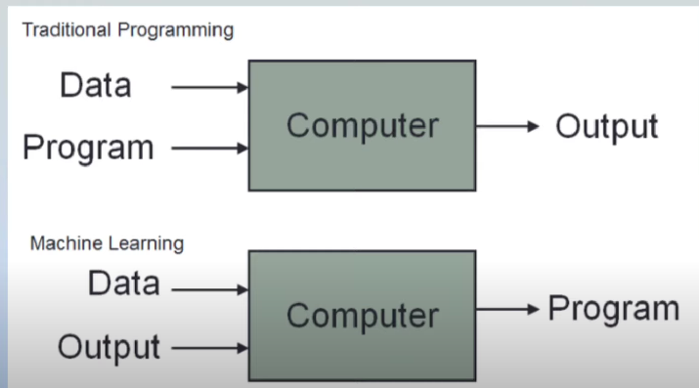

Types

**Supervised ML**- input and output both.

Regression

Classification

**Unsupervised ML-** Only input

Clustering

Dimensionality Reduction

Anamoly Detection

Association Rule Learning

**Semi-supervised-** Ex Google photo label

**Reinforcement-** self driving car

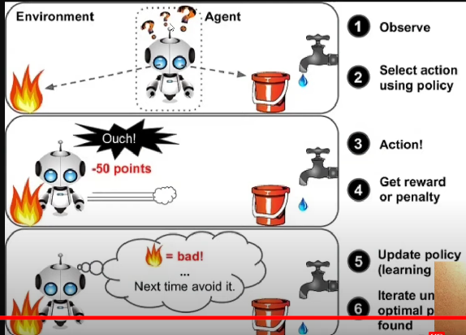

**4**.**Batch Machine Learning (offline) vs Online Learning**

**Offline Learning**

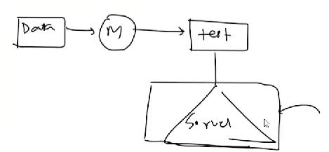

The problem

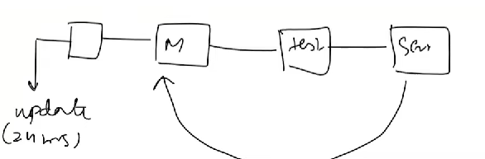

Disadvantage

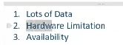

**5. Online ML Learning**

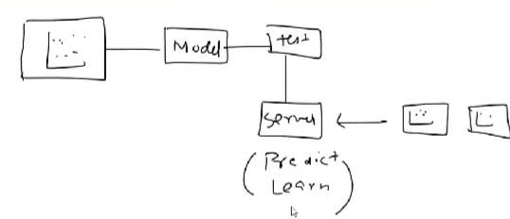

Example: Chatbot, youtube.

When to use Online Learning?

1. Where there is a concept drift
2. Cost Effective
3. Faster Solutions

Disadvantage:

* Tricky to use
* Risk

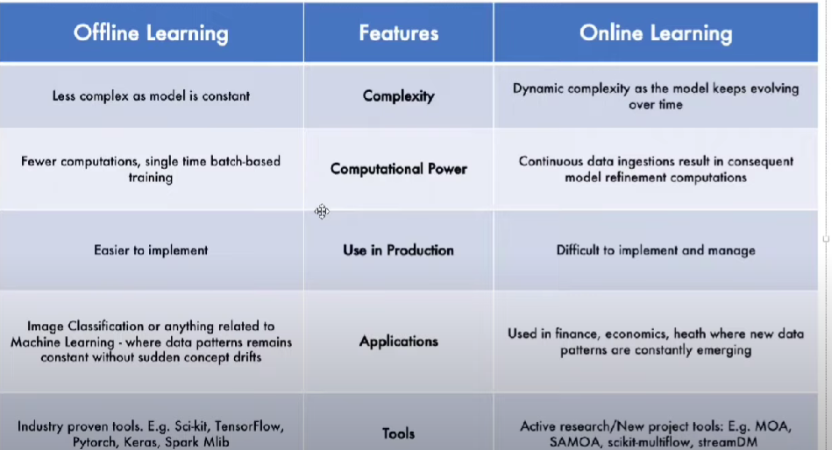

**6. Instance – Based Vs Model-based Learning**

Instance Based

Example KNN,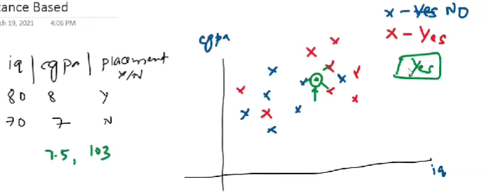

Model -Based Learning

Example – Linear regression

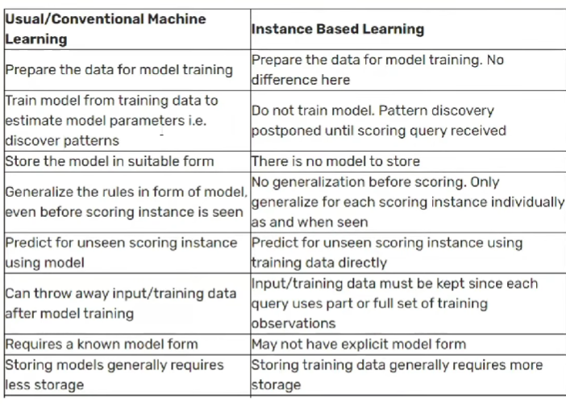

**7. Challenges in ML**

1) **Data Collection:**

2) **Insufficient Data/Labelled:**

3) **Non-Representation Data**: Sampling noise, sampling bias

4) **Poor Quality Data:**

5) **Irrelevant Features:** Garbage In Garbage Out

6) **Overfitting:**

7) **Underfitting:**

8) **Software Integration:**

9) **Offline Learning/Deployment:**

10) **Cost Involved:**

**8. Application of Machine Learning**

* **Retail – Amazon/Big Bazaar:**
* **Banking and Finance:**
* **Transport – QLA:**
* **Manufacturing – Tesla:**
* **Consumer Internet – Twitter:**

**9. Machine Learning Development Life Cycle (MLDC)**

**1) Frame the Problem:**

**2) Gathering Data:** CSV, API, web scraping, Database (Data warehouse)

**3) Data Preprocessing:**

**4) Exploratory Data Analysis**: visualization, univariate / Bivariate, outlier detection, Imbalance

**5) Feature Engineering and selection:**

**6) Model Training Evaluation and selection:** Ensemble learning

**7)Model Deployment:**

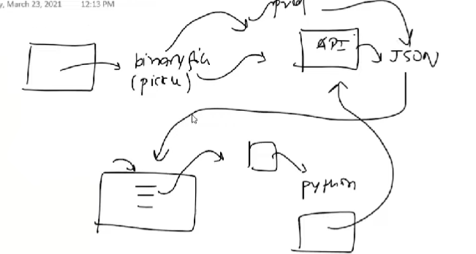

**8) Testing:** A/B testing

**9) Optimize:** Backup, Data, Load balancing

**10 Data Engineer vs Data Analyst vs Data Scientist Vs ML Engineer**

**Various Data based**

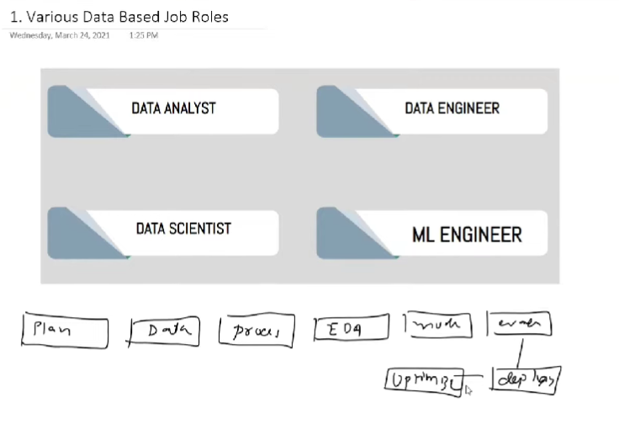

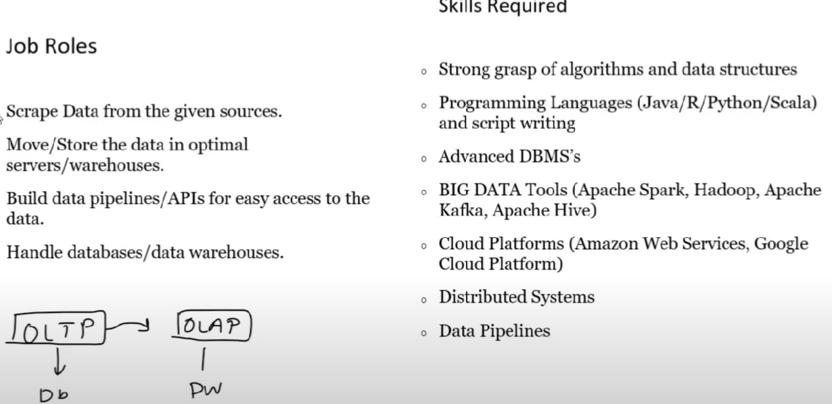

**Data Analyst**

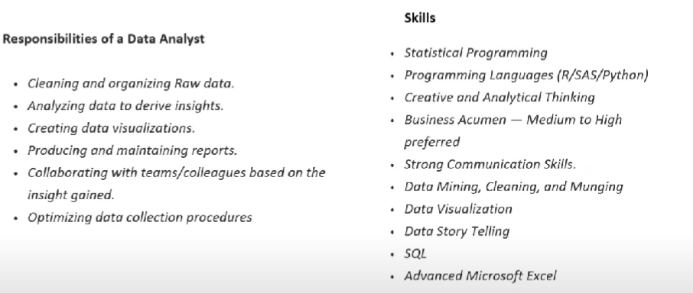

**Data Scientist:**

"A data scientist is someone who is better at statistics than any software engineer and better at software engineering than any statistician".

**ML Engineer**

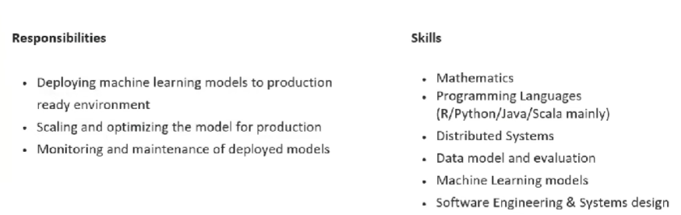

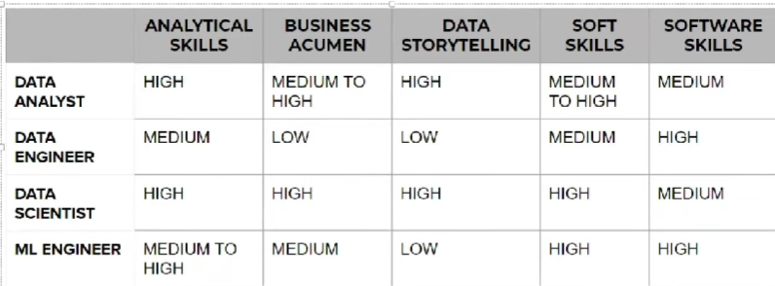

**11. What are Tensors**

**One Dimension Tensor/vector**: [1,2,3,4]

**Two Dimension Tensor/Matrices: [1,2,3] [4,5,6] [7,8,9]**

**N- Dimension Tensor:**

**Rank, Axis and Shape:**

**Example of 1D Tensors:**

**Example of 2D Tensors**:

**Example of 3D Tensors**: Time series Data (Highest | lowest)

**Example of 4D Tensors**: Images

**Example of 5D Tensors**: Videos

**14. How to Frame a Machine Learning Problem**

1) Business Problem to ML Problem:

2) Type of Problem:

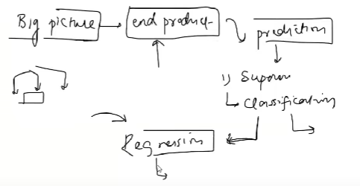

3) Current Solution:

4) Gathering Data:

* Watch time
* Search but did not find
* Content left in the middle
* Clicked on recommendations (order of recommendation)

5) Metrics to measure:

6) Online vs Batch:

7) Check Assumptions

15. Working with CSV files

Data Gathering: CSV, JSON/SQL, Fetch data from API, Web scraping

<https://pandas.pydata.org/docs/reference/api/pandas.read_csv.html>

16 Working with JSON/SQL

<https://pandas.pydata.org/docs/reference/api/pandas.read_json.html>

17. Fetching Data from an API

What is an API?

<https://developer.themoviedb.org/docs/getting-started>

<https://rapidapi.com/collection/list-of-free-apis>

<https://jsonviewer.stack.hu/>

23 What is Feature Engineering

Feature engineering is the process of using domain knowledge to extract features from raw data. These features can be used to improve the performance of machine learning algorithms.  
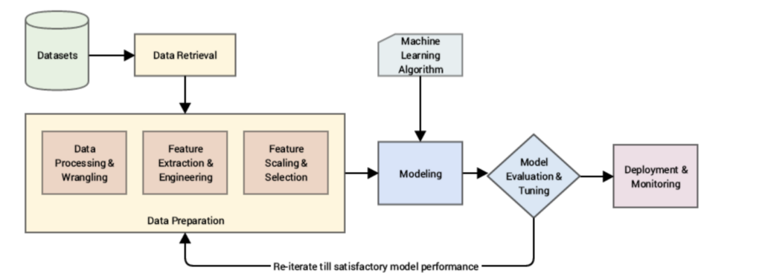

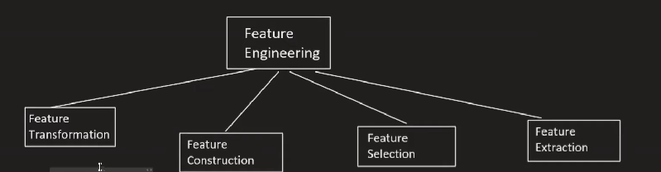

1.1 Missing values imputation

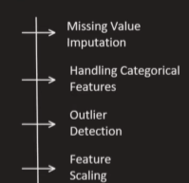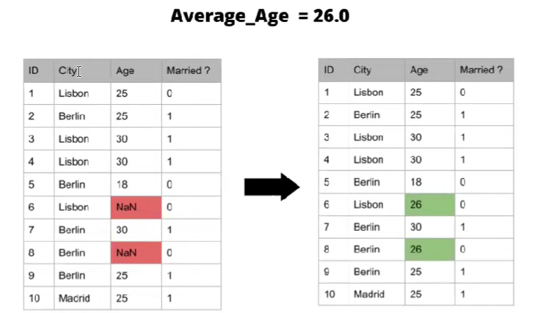

1.2 Handling categorical Values

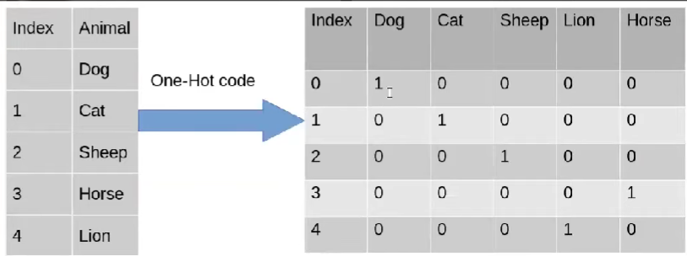

1.3 Outlier Detection

1.4 Feature Scaling

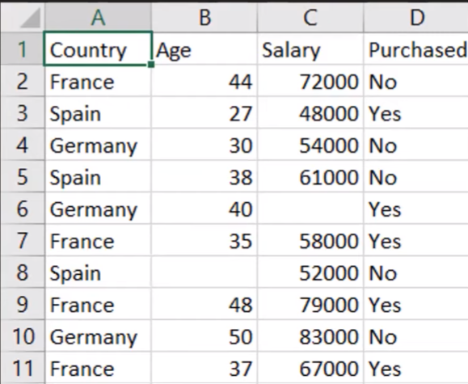

2. Feature Construction

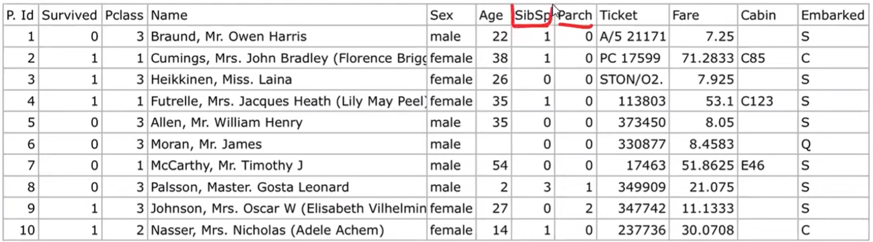

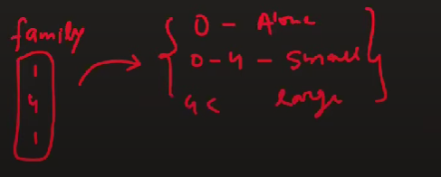

3) Feature Selection:

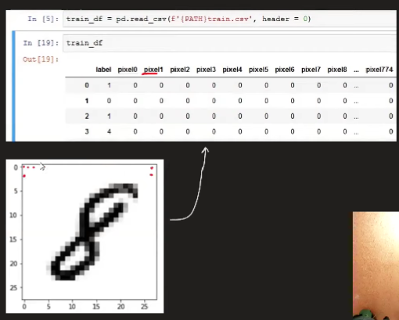

4) Feature Extraction:

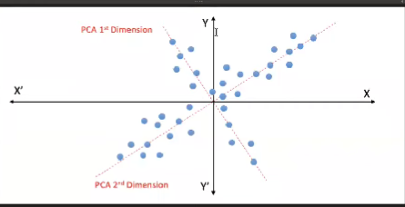

# 24 Feature Scaling - Standardization

Why do we need Feature Scaling?

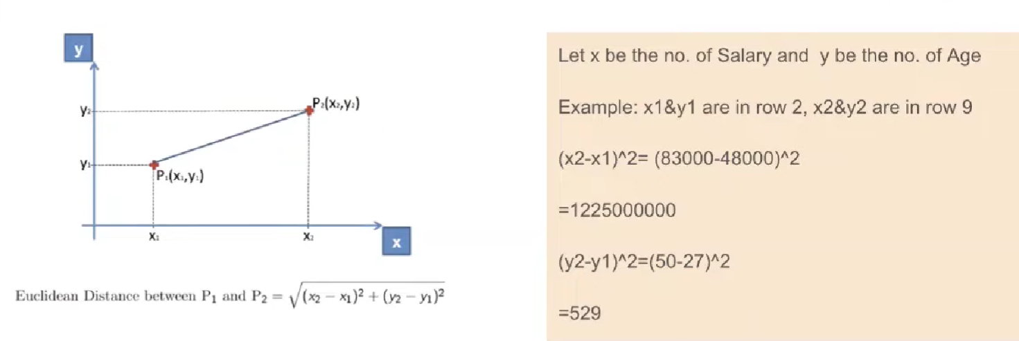

Types of Feature Scaling

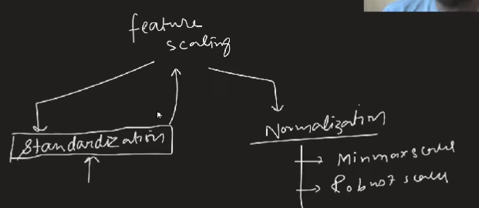

Standardization – Intuition

Also called as Z – score Normalization

Example:

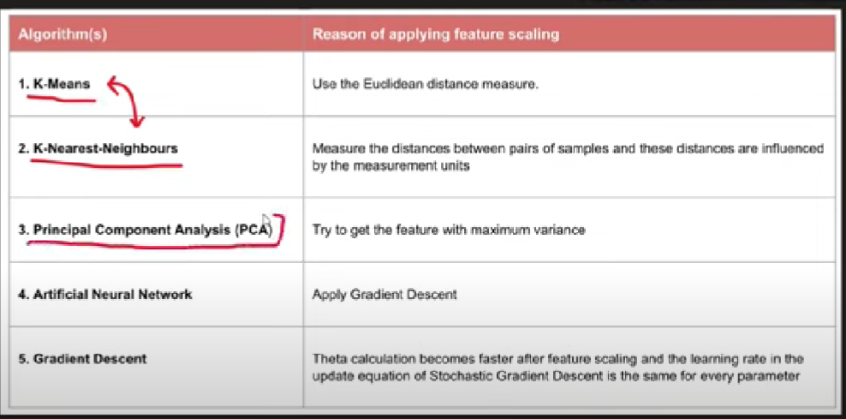

25. **Feature Scaling - Normalization | MinMaxScaling | MaxAbsScaling | RobustScaling**

**Normalization:**

Normalization is a technique often applied as part of data preparation for machine learning. The goal of normalization is to change the values of numeric columns in the dataset to use a common scale, without distorting differences in the ranges of values or losing information

**Minmax Scaling – Intuition:**

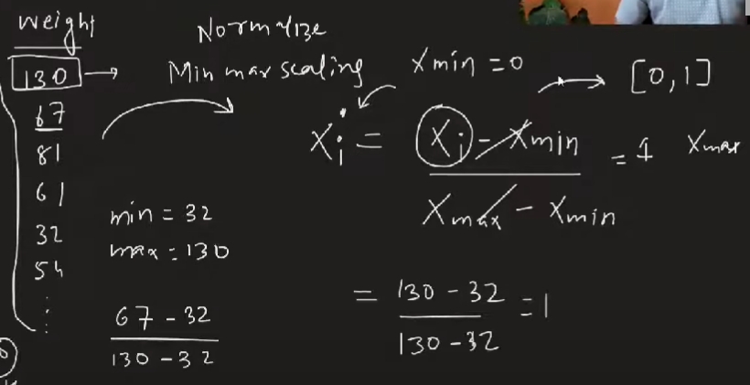

Mean Normalization:

MaxAbs Scaling:

Robust Scaling:

Normalization vs Standardization:

26. **Encoding Categorical Data | Ordinal Encoding | Label Encoding**

**Encoding Categorical Variables**:

Ordinal Encoding

**27 One Hot Encoding | Handling Categorical Data**

**One Hot Encoding**

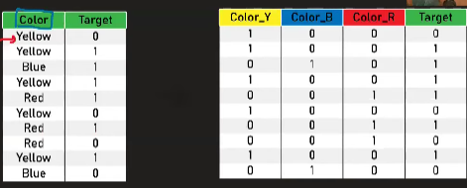

**Dummy Variable Trap:**

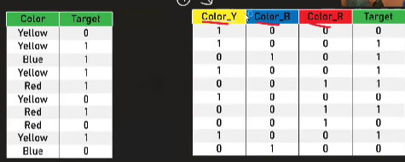

**OHE using most frequent Variable:**

**Example**:

28. **Column Transformer in Machine Learning | How to use Column Transformer in Sklearn**

Column Transformer

**29.** **Machine Learning Pipelines A-Z**

**Scikit Learn Pipelines:**

Pipelines chains together multiple steps so that the output of each step is used as input to the next step.

Pipelines makes it easy to apply the same preprocessing to train and test!

30. **Function Transformer | Log Transform | Reciprocal Transform | Square Root Transform**

**Mathematical Transformations:**

How to find if data is normal?

QQ Plots

Log Transform

**Other Transform**

* Reciprocal (1/x)
* Square (x2)
* Sqrt

31 **Power Transformer | Box - Cox Transform | Yeo - Johnson Transform**

Power Transform

https://scikit-learn.org/dev/modules/generated/sklearn.preprocessing.PowerTransformer.html#sklearn-preprocessing-powertransformer

Box Cox Transform:

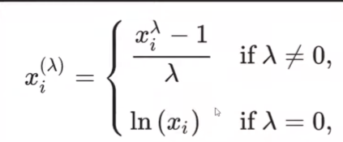

The exponent here is a variable called lambda (A) that varies over the range of -5 to 5, and in the process of

searching, we examine all values of λ. Finally, we choose the optimal value (resulting in the best approximation to a normal distribution) for your variable.

32. **Binning and Binarization_Discretization_Quantile Binning_KMeans Binning**

1) Encoding Numerical Features

2) Discretization (Binning)

Discretization is the process of transforming continuous variables into discrete variables by creating a set of contiguous intervals that span the range of the variable's values. Discretization is also called binning, where bin is an alternative name for interval.

Why use Discretization:

1. To handle Outliers

2. To improve the value spread

Types of Discretization

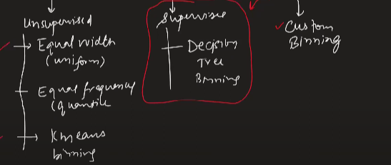

4) Equal Width / Uniform Binning

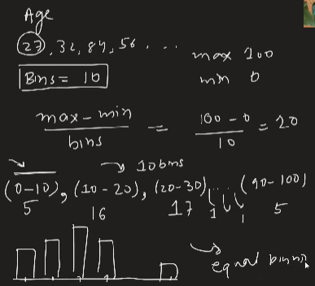 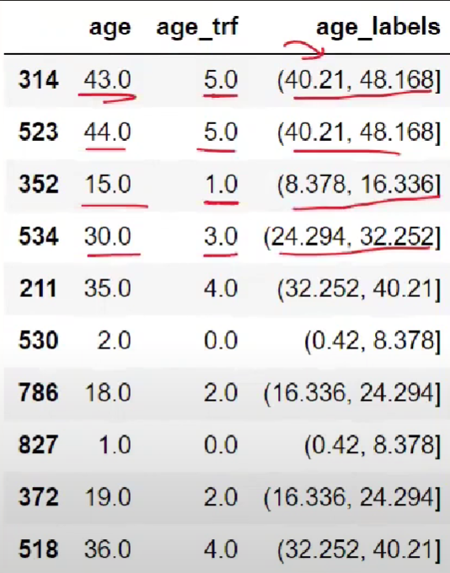

5) Equal Frequency/ Quantile Binning

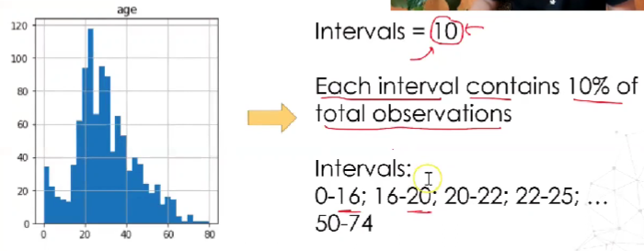

6) KMeans Binning

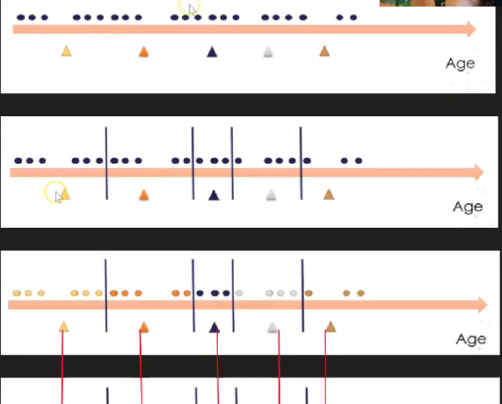

7) Encoding the discretized variable

8)Example

9) Custom/Domain Based Binning

10) Binarization

11) Example

33 **Handling Mixed Variables | Feature Engineering**

Mixed Data:

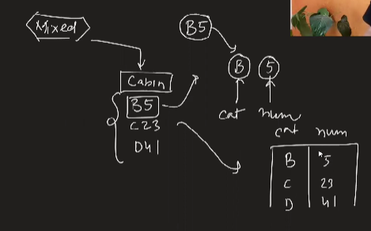

34 **Handling Date and Time Variables**

Working with date and time

35 **Handling Missing Data | Part 1 | Complete Case Analysis**

Handling Missing Data

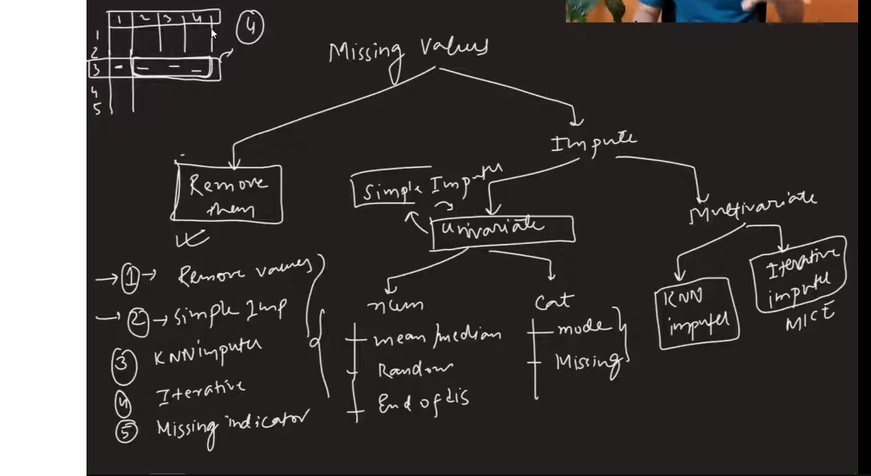

Complete-case analysis (CCA), also called "list-wise deletion" of cases, consists in discarding observations where values in any of the variables are missing.

ابى

Complete Case Analysis means literally analyzing only those observations for which there is information in all of the variables in the dataset.

**Assumption for CCA**

**Advantage/Disadvantage**

Advantage

1. Easy to implement as no data manipulation required

2. Preserves variable distribution (if data is MCAR, then the distribution of the variables of the reduced dataset should match the distribution in the original dataset

**Disadvantage**

1. It can exclude a large fraction of the original dataset (if missing data is abundant)

2. Excluded observations could be informative for the analysis (if data is not missing at random)

3. When using our models in production, the model will not know how to handle missing data

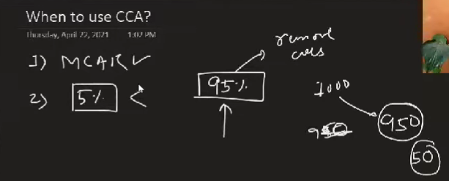

36. **Handling missing data | Numerical Data | Simple Imputer**

1) Handling Missing Numerical Data

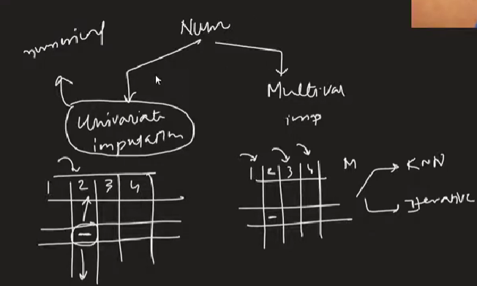

2) Mead/Median Imputation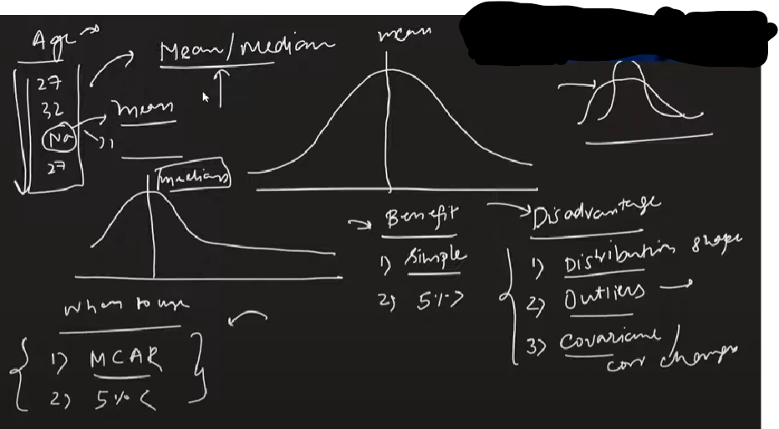

3. Arbitrary Value Imputation

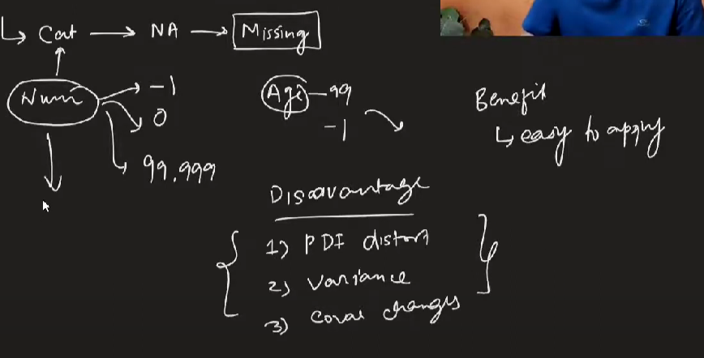

4) End of Distribution Imputation

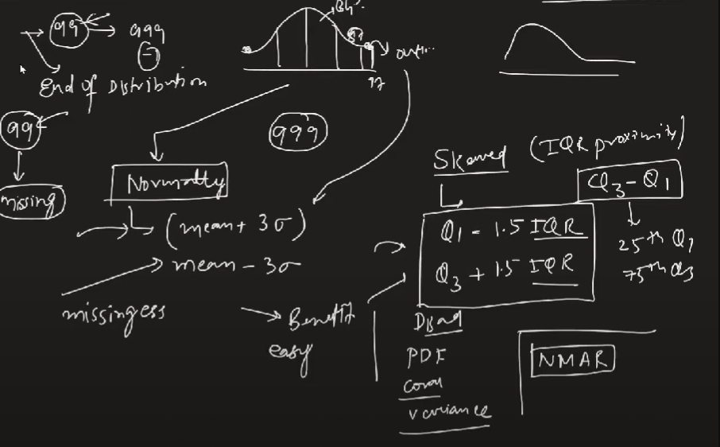

37 **Handling Missing Categorical Data | Simple Imputer | Most Frequent Imputation**

Handling Missing Categorical Data

Most Frequent Value Imputation

Missing Category Imputation

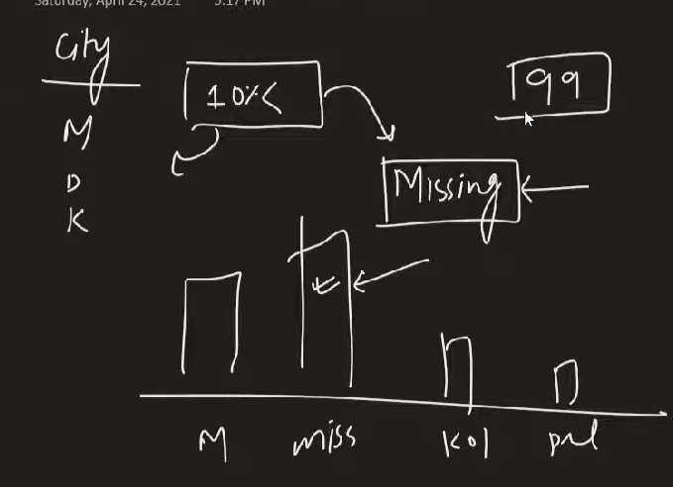

**38 Missing Indicator | Random Sample Imputation | Handling Missing Data**

**Random Imputation**

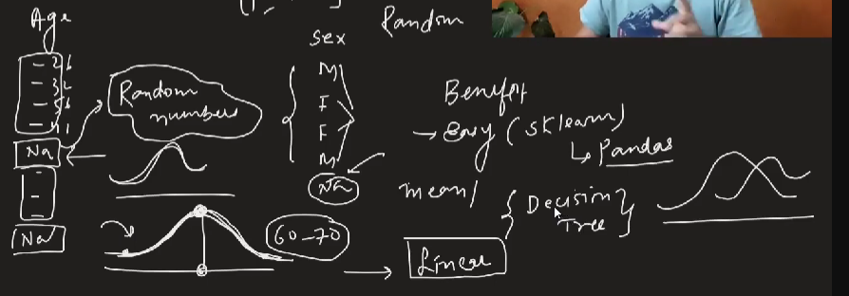

1. Preserves the variance of the variable (But why?)

2. Memory heavy for deployment, as we need to store the original training set to extract values from and

replace the NA in coming observations

3. Well suited for linear models as it does not distort the distribution, regardless of the % of NA

**Missing Indicator**

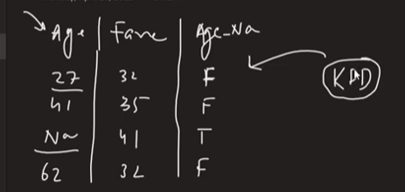

Automatically

39 **KNN Imputer | Multivariate Imputation | Handling Missing Data**

**KNN Imputer**

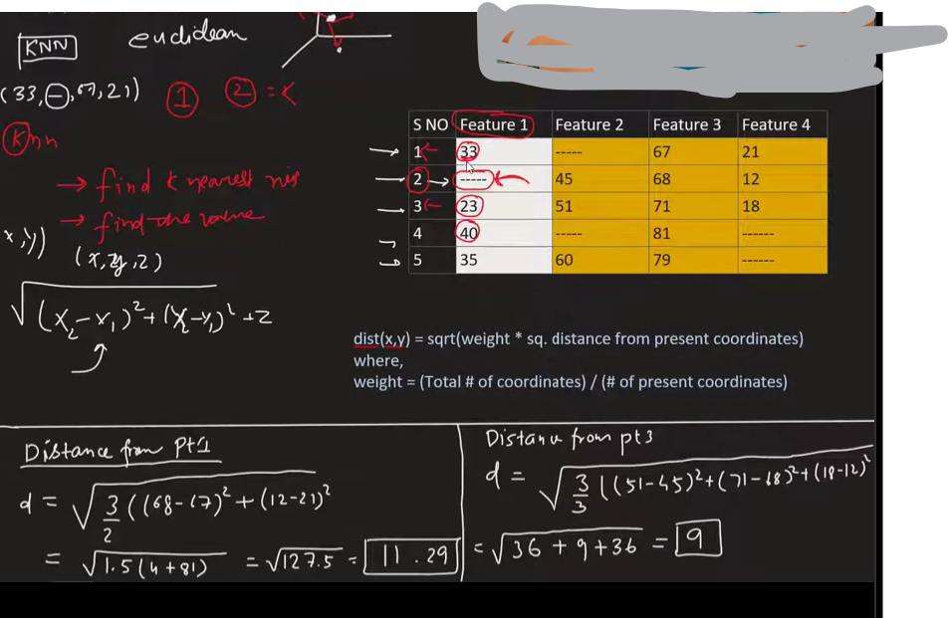

40. **Multivariate Imputation by Chained Equations for Missing Value | MICE Algorithm | Iterative Imputer**

1) Actual Dataset

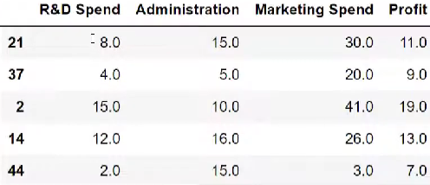

2) Removing the target column

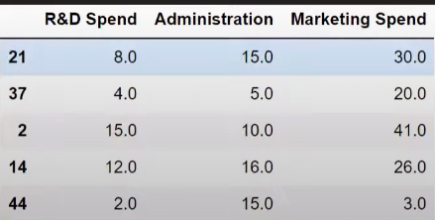

3) Introduced some fake nan values

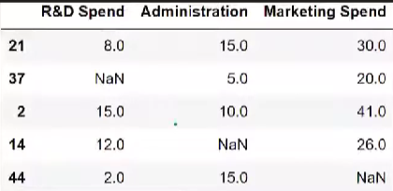

Step 1- Fill all the NaN values with mean of respective cols

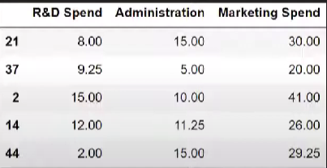

Step 2 – Remove all col1 missing values

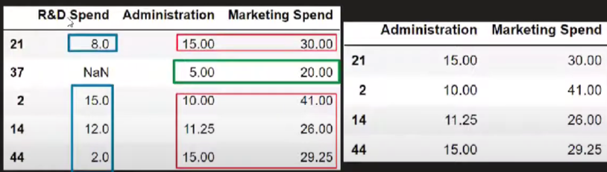

Step3 – Predict the missing Values of col1 using other cols

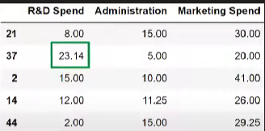

Step 4 – Remove all col2 missing values

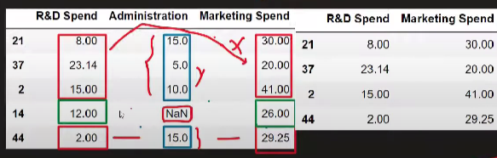

Step5 – Predict the missing values of col2 using other cols

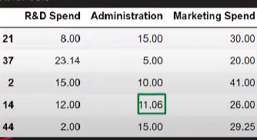

Step 6 – Remove all col3 values

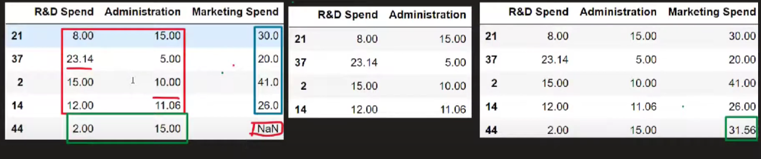

Iteration 0

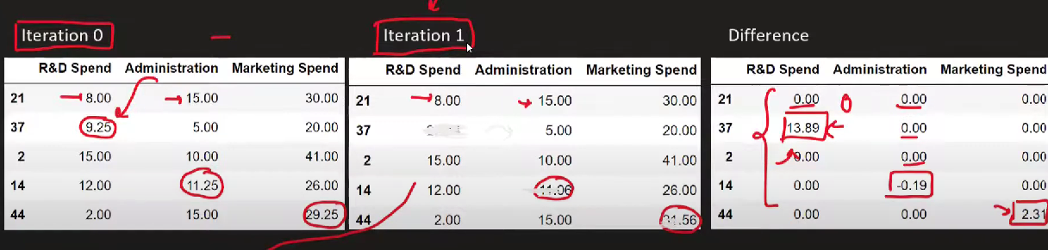

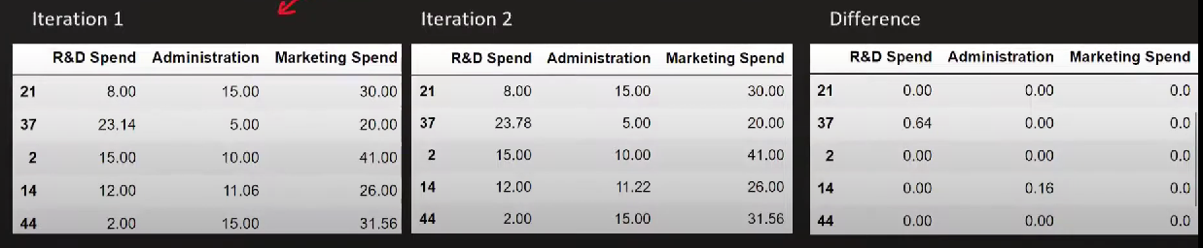

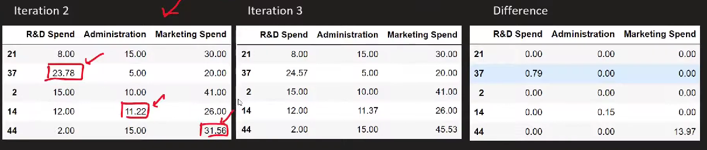

**40. Multivariate Imputation by Chained Equations for Missing Value MICE Algorithm Iterative Imputer**

1) Actual dataset

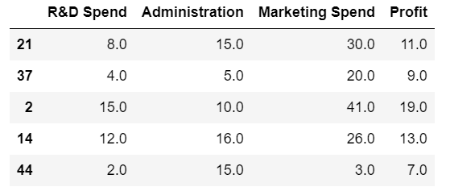

2) Removing the target Column

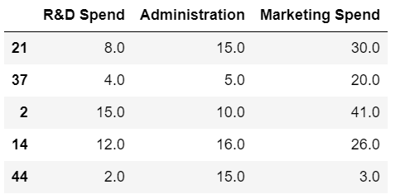

3) Introduced Some fake nan Values

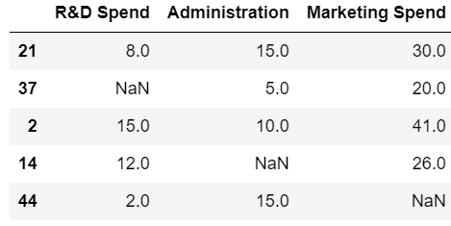

Step 1: Fill all the NaN values with mean of

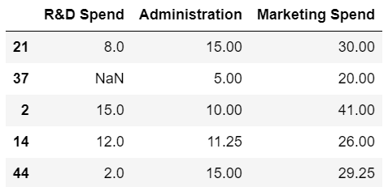

Step 2: Remove all col1 missing values

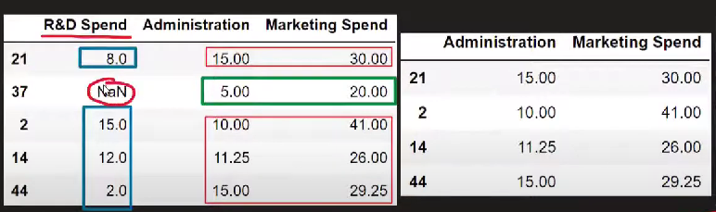

Step 3: Predict the missing values of col1 using other cols

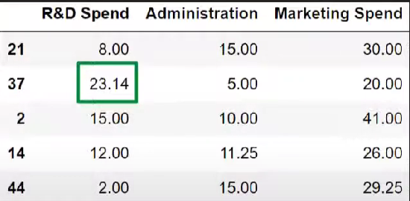

Step 4: Remove all col2 missing values

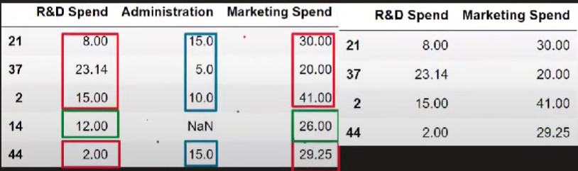

Step 5: Predict the missing values of col2 using others cols

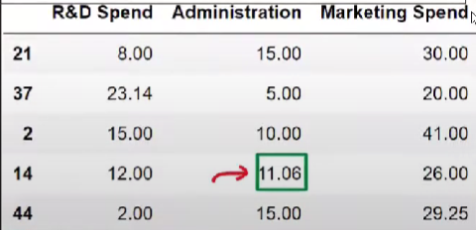

Step 6: Remove all col3 values

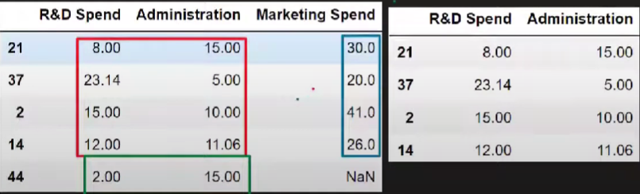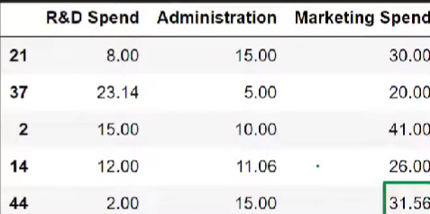

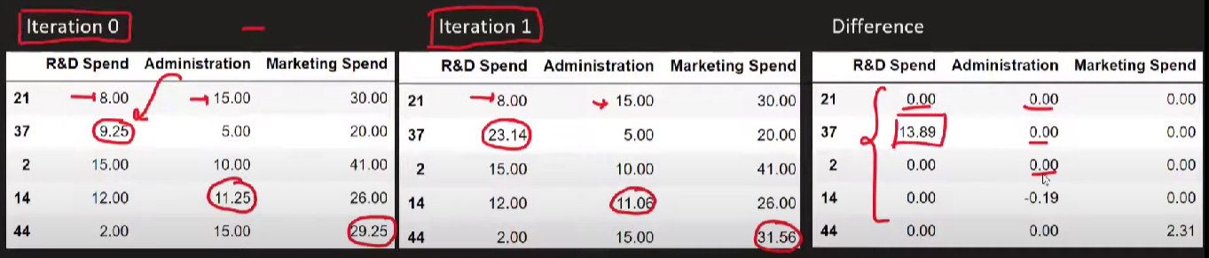

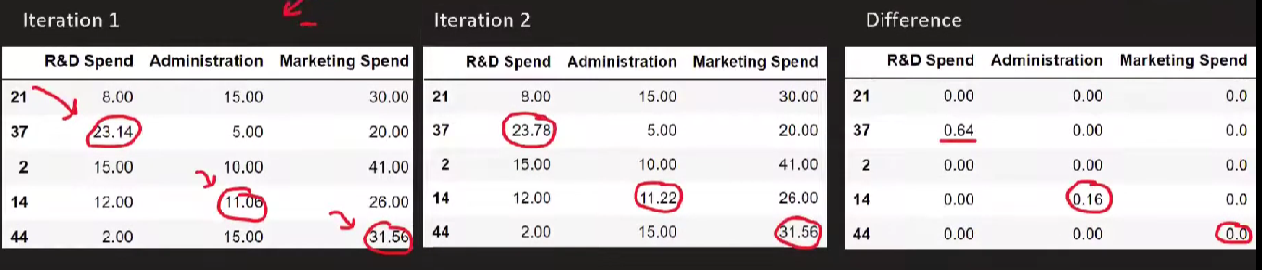

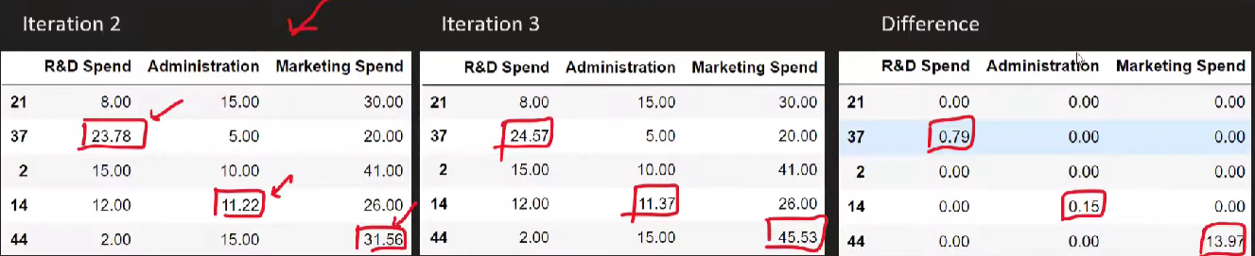

**41** **What are Outliers | Outliers in Machine Learning**

**What are Outliers?**

**When is outlier dangerous?**

Anamoly detection

**Effect of Outliers on ML algorithms**

**How to treat Outliers?**

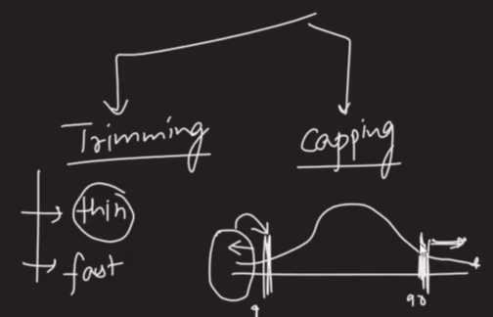

1)Normal Distribution

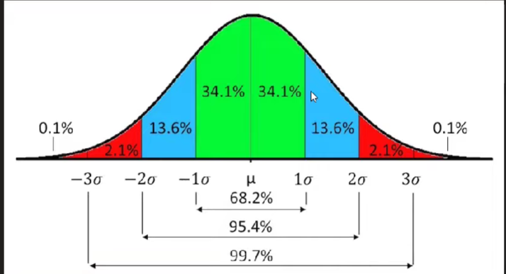

2) Skewed Distribution

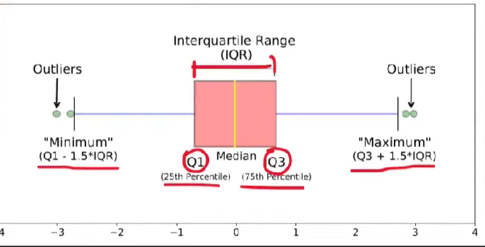

3) Other Distributions

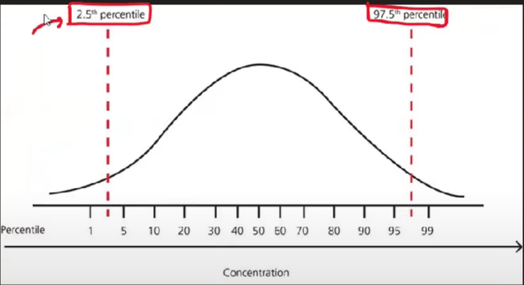

Techniques for Outliers Detection and Removal

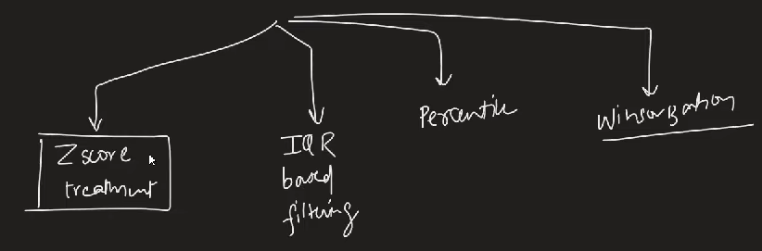

42 **Outlier Detection and Removal using Z-score Method | Handling Outliers**

Outliers’ removal using Z – score

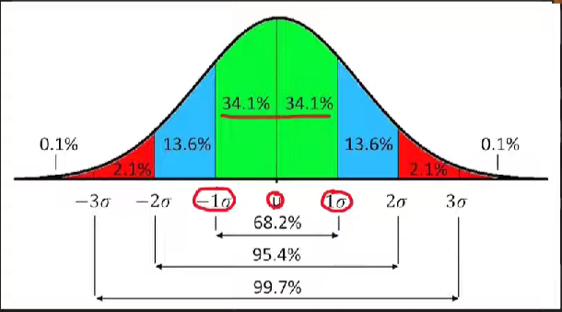

43 **Outlier Detection and Removal using the IQR Method**

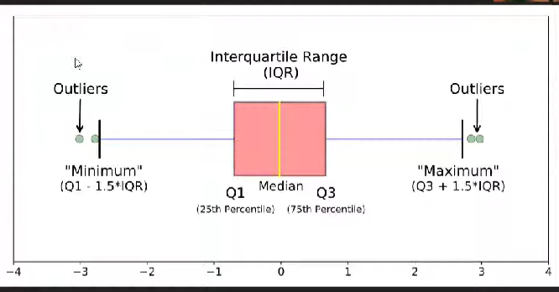

44 **Outlier Detection using the Percentile Method | Winsorization Technique**

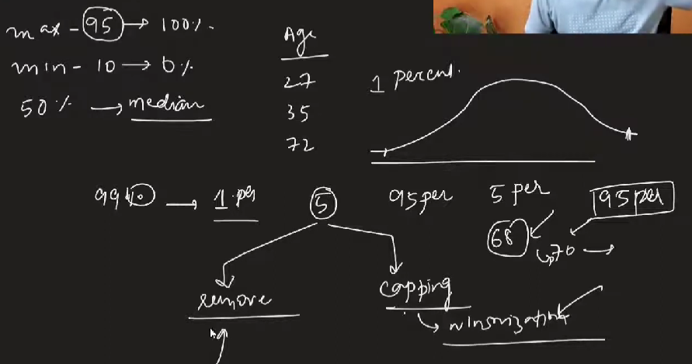

45 **Feature Construction | Feature Splitting**